FYPJ Documentation

EMGRID:

Learning Programming With Drag & Drop

Project Members:

Edric Tan (182821D)

Sonya Boey (184727J)

**TABLE OF CONTENTS**

**1.** **About This Project****………………………………………………………………………………. 3**

**2.** **Installation and Setting up of OpenJDK 11****…………………………………………………. 4**

**3. Installation and Setting up of Apache NetBeans 12.1****…………………………………….. 7**

**4. Adding OpenJDK 11 to Apache NetBeans 12.1 as a Java platform****…………………... 12**

**5. Adding the necessary jar files to the project****……………………………………………… 15**

**6. Navigating The Application (User Guide)****………………………………………………….. 20**

## About This Project

Project Name:

Mini IDE (Drag & Drop) Program

Supervisor:

Mr Teh Ah Hock

Acad Year Period:

AY2020/ P4

Project Description:

Mini IDE Drag & Drop Program is developed to work similar to a simple mini IDE where it will be showcased to visitors during NYP open house or something else that is similar in setting. The goal of the program is to teach the fundamentals and/or basics of programming through dragging and dropping. We hope that through this program, non-programmers who are interested in programming but are unsure of how to, will serve as a guide to understand the workflow of how programming works.

*Note:

This project is done with Java Swing in Netbeans. The program is to teach the basics/ logic-flow of programming as a whole (Not just addressing Java programming).

## Installation and Setting up of OpenJDK 11

1. You will need an Oracle account for this part of the installation process. Create a free account at <https://profile.oracle.com/myprofile/account/create-account.jspx>
2. Go to <https://www.oracle.com/java/technologies/javase-jdk11-downloads.html>
3. Scroll and double click the download link for Windows x64 Installer version of the Java SE Development Kit 11.0.9 (highlighted below).

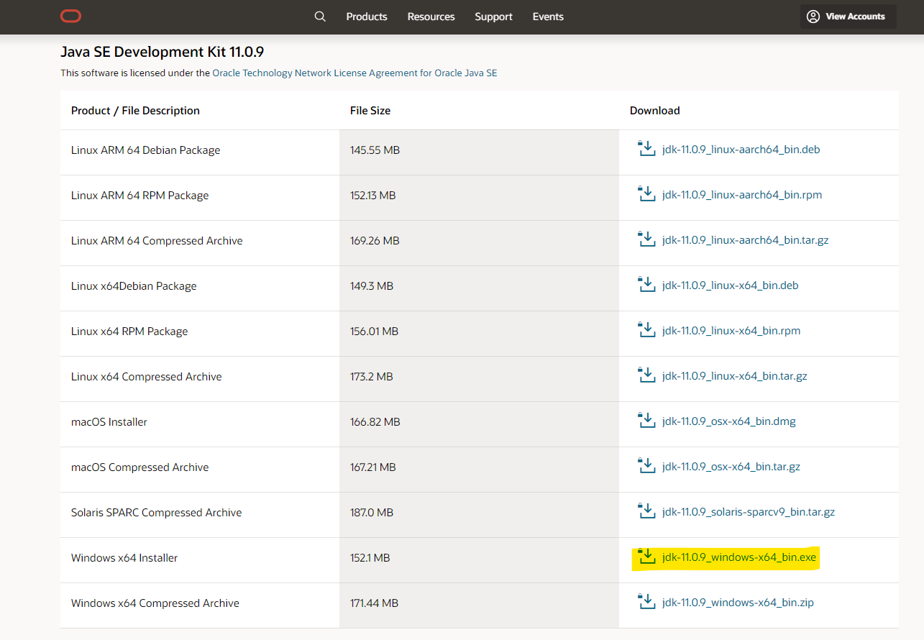

1. In the popup, tick the checkbox and then click the Download button.

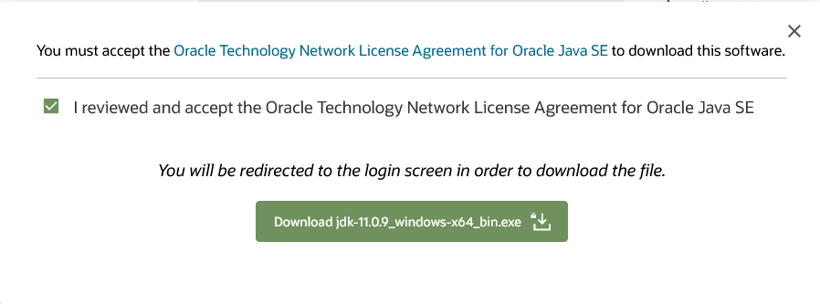

1. Enter your credentials for your Oracle account once you are redirected, then, click Sign In. The download will start automatically.

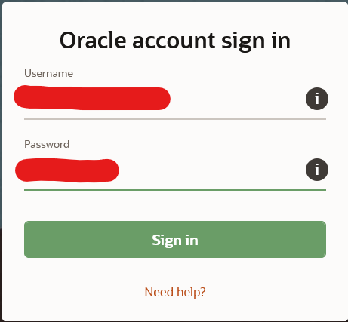

1. Once the file is downloaded, run the .exe file.
2. Allow the application to make changes to your computer (requires administrator privilege).

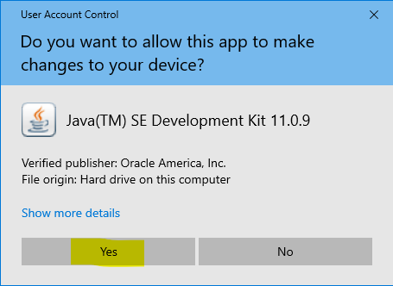

1. Click Next.

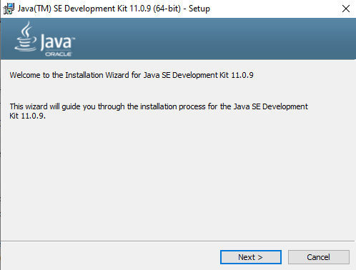

1. Click Next.

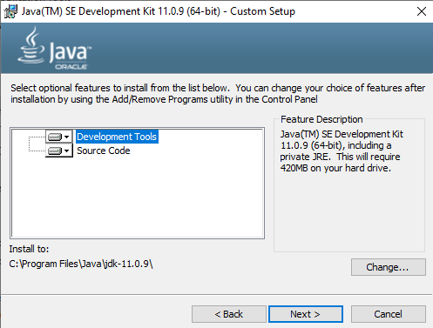

1. Click Close.

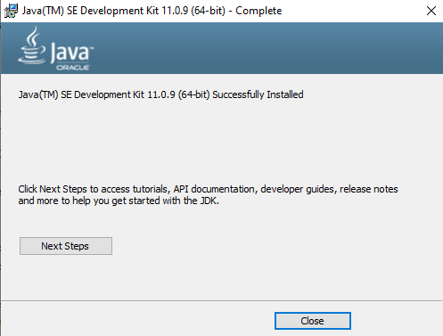

1. OpenJDK 11 has been successfully installed.

## 3. Installation and Setting up of Apache NetBeans 12.1

1. Go to <https://netbeans.apache.org/download/nb121/nb121.html>
2. Double click on Apache-NetBeans-12.1-bin-windows-x64.exe ( SHA-512, PGP ASC) link

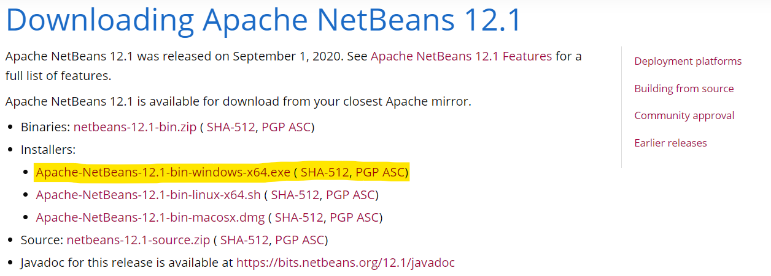

1. Double click on the highlighted link under “HTTP” shown in the image below on the page you’re redirected to. The download will start automatically.

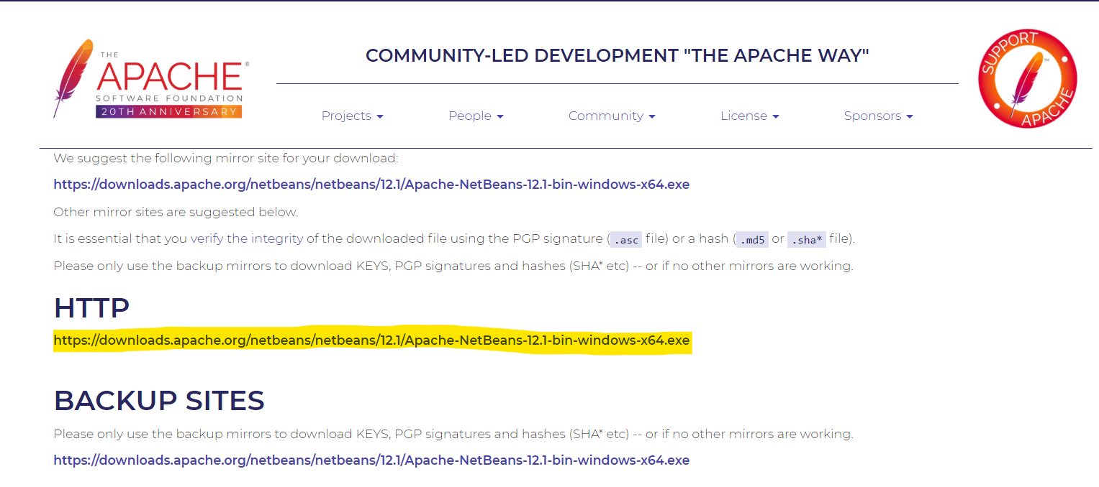

1. Run the downloaded .exe file.
2. Allow the application to make changes to your computer (requires administrator privilege).

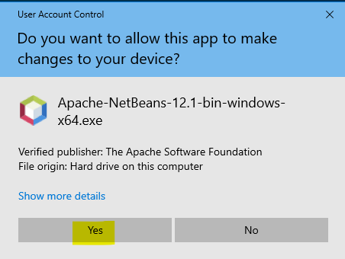

1. Click Next.

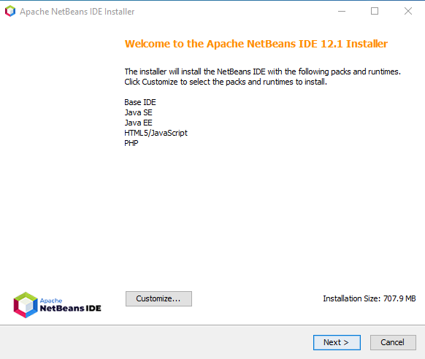

1. Make sure to tick “I accept the terms in the license agreement”, then, click Next.

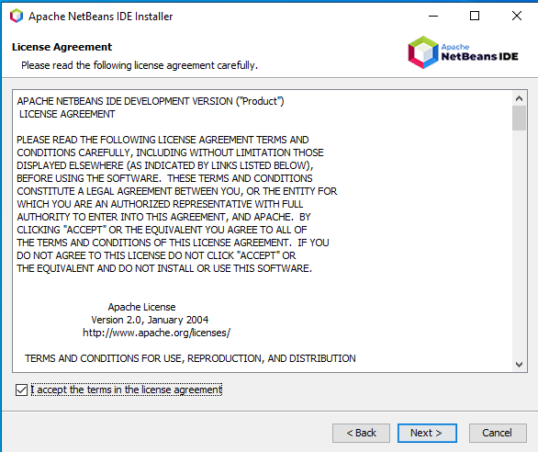

1. Set the directories of the installation folder and JDK for the Apache NetBeans IDE as shown below, then, click Next.

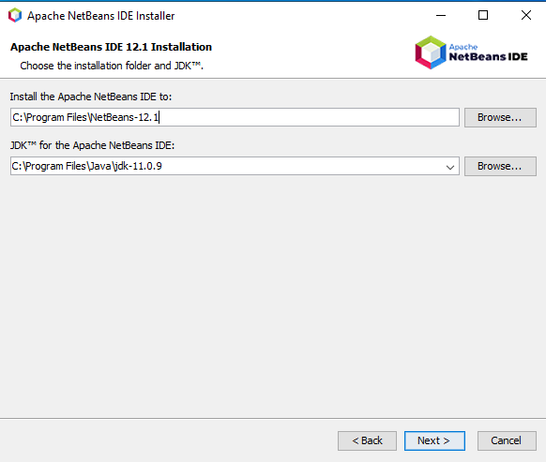

1. Ensure the checkbox for “Check for Updates” is ticked, then click Install.

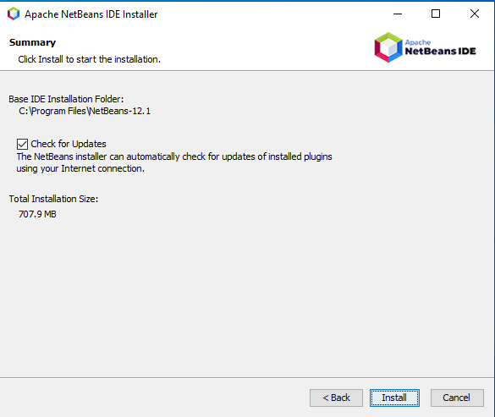

1. Once the installation has finished, click Finish.

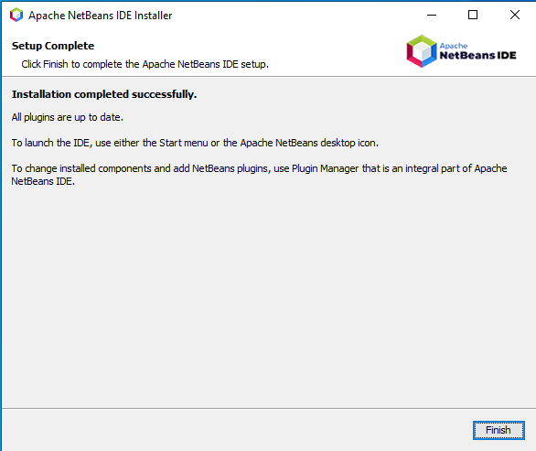

1. You have successfully installed Apache NetBeans 12.1.

## 4. Adding OpenJDK 11 to Apache NetBeans 12.1 as a Java platform

If, when installing Apache NetBeans 12.1, you had used a different JDK for the Apache NetBeans IDE instead of OpenJDK 11.

1. Go to Tools > Java Platforms in the menu bar.

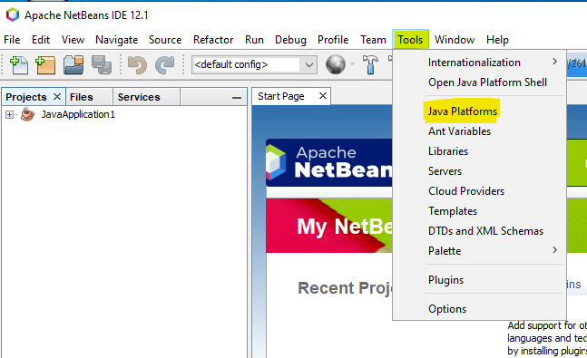

1. Double click Add Platform… in the popup window.

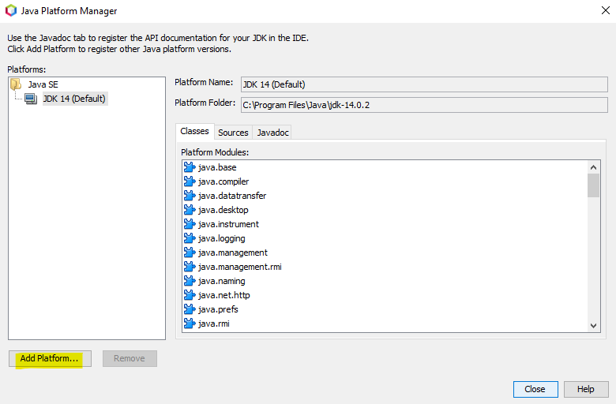

1. In the popup window, ensure “Java Standard Edition” is selected, then, click Next.

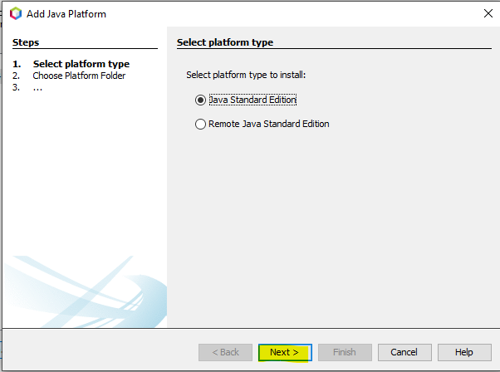

1. Find for the directory that OpenJDK 11 has been installed to, then, click Next.

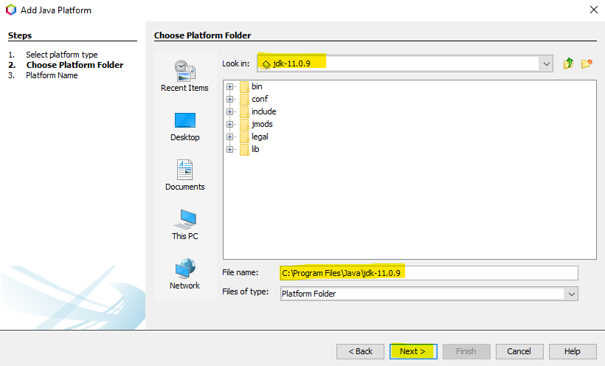

1. Ensure the fields in the next page are filled as such, then click Finish.

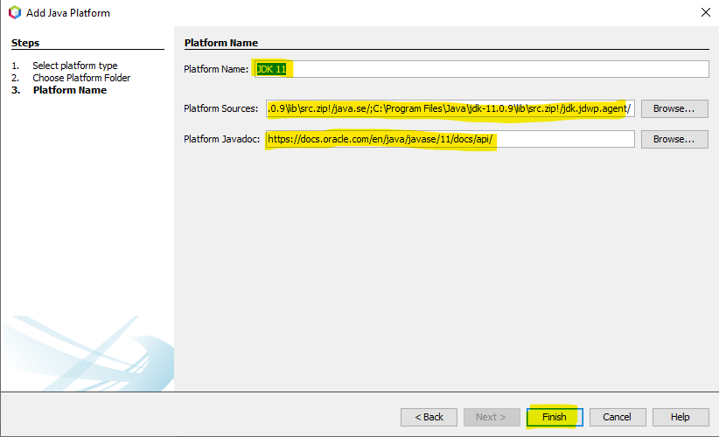

1. Click Close.

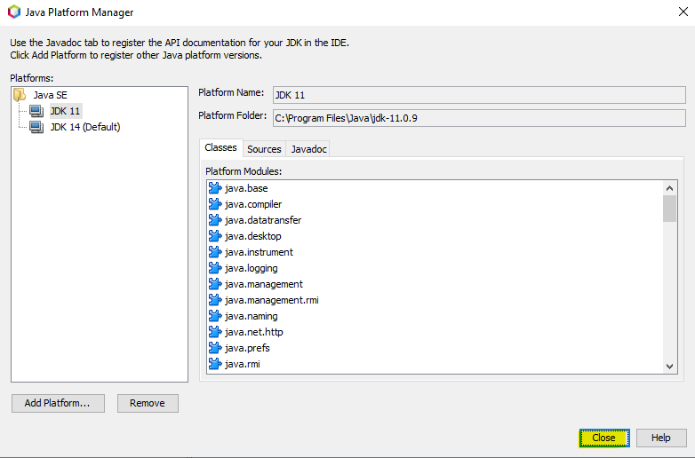

1. You have now successfully added OpenJDK 11 to your Apache NetBeans 12.1.

## 5. Adding the necessary jar files to the project

This section is to include all the necessary jar files that the project imported and used, which are external from NetBeans. This section can also be used as a guide to add any other JAR files that you might want to import into the FYP Project.

JAR files are a form of extension to expand the functionalities and methods of Java.

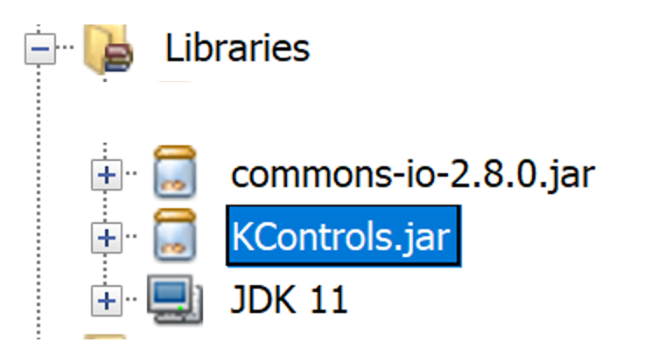

This screenshot lists the jar files that are needed in this project. An example of how to import the jars into the project can be seen below.

1. Go to Project > Libraries, then left click and click on Add JAR/Folder…, under Projects panel.

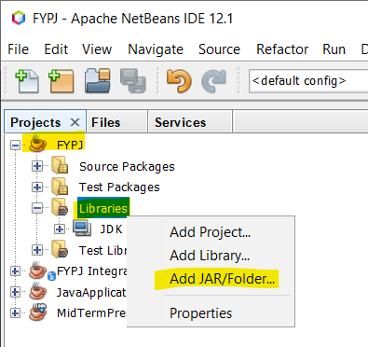

1. Choose the JAR file, then click Open.

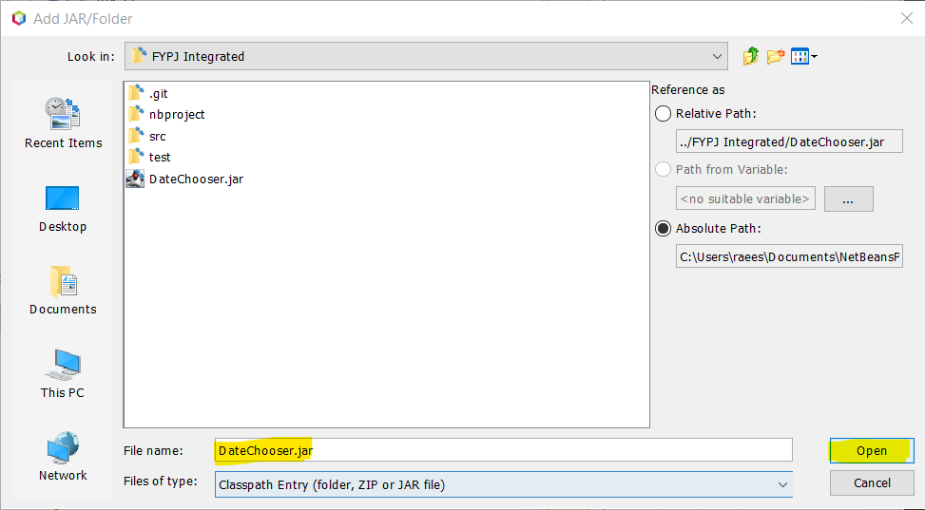

1. You should now be able to see the JAR file added under Libraries.

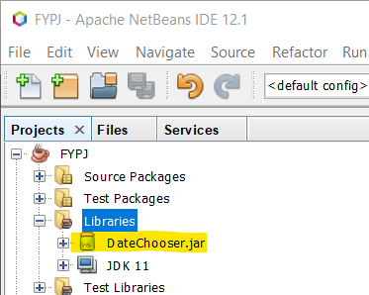

1. You have now successfully added the JAR file to the project.

Note that for “commons-io-2.8.0.jar”, there will be additional steps to follow, as listed below:

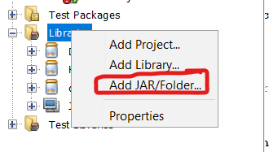

1. Same as before, under Project, right click on Libraries and select “Add JAR/Folder”.

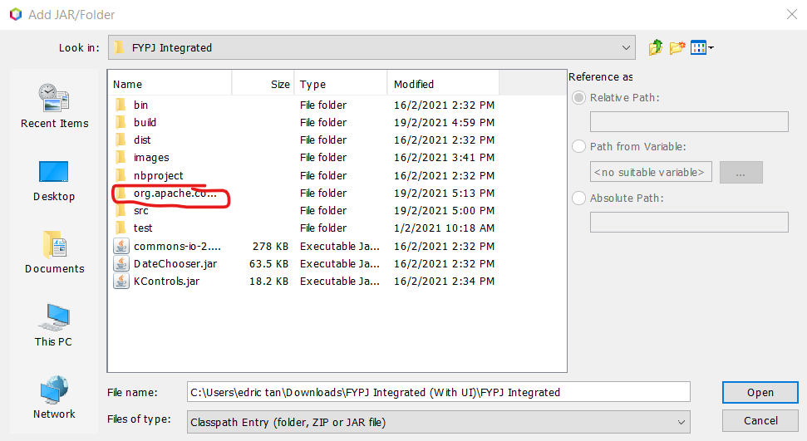

1. Navigate to “org.apache.commons.io.jar” folder

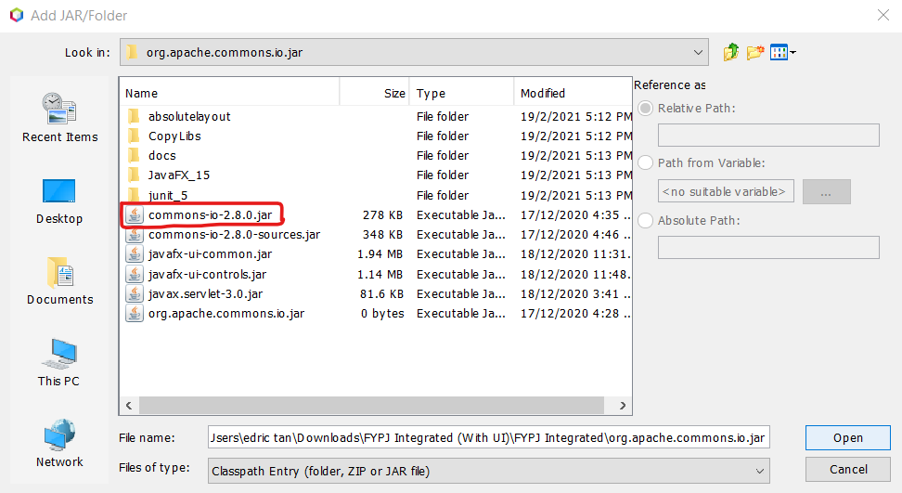

1. Select and add “commons-io-2.8.0.jar” file

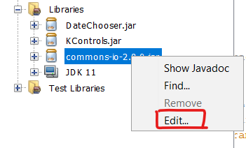

1. On top of adding the jar file, we need to include the sources and Javadoc. For this, navigate to Project>Libraries, and right click on the “commons-io-2.8.0.jar” library. Select “Edit...”

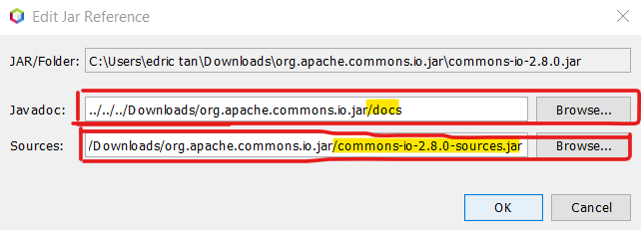

1. As follows, within the “org.apache.commons.io.jar” folder, locate and add the following files, “docs” for Javadoc and “commons-io-2.8.0-sources.jar” for Sources

## 6. Navigating The Application (User Guide)

1. Open Apache Netbeans 12.1
2. Right click to run the application “DragAndDropIcon444. java”, or simply click the green play button located in the menu bar for debugging.

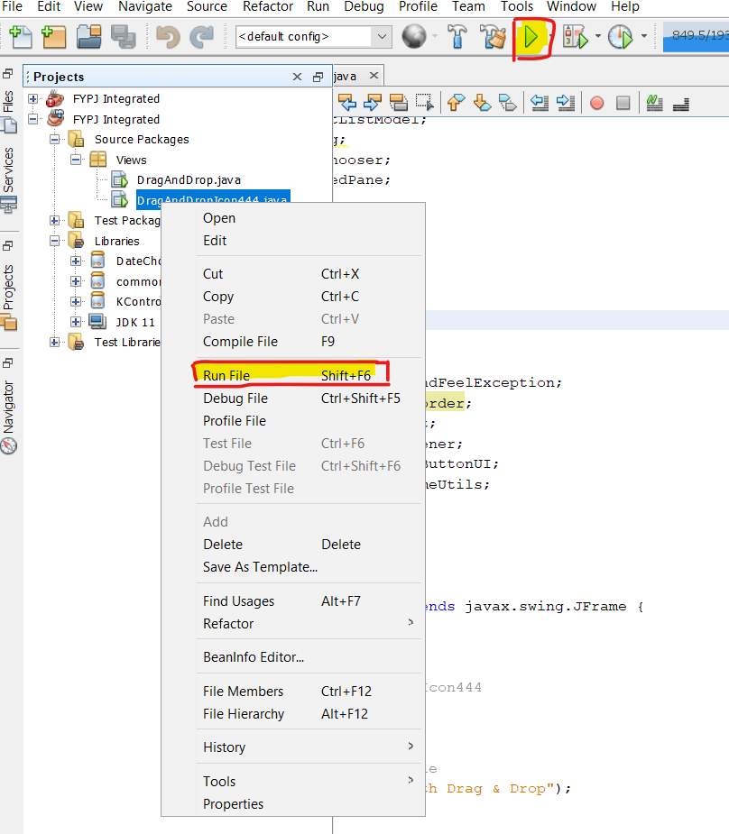

Our application has the following set of features:

1. Add/Remove Files
2. Drag and Drop filename AND moving icons
3. Drawing of lines to connect “file drop area” to functions
4. Executing workflow user has supplied

Click on the link below to learn how to navigate around our mini IDE! Do not forget to have fun and we hope you learn the basics of programming. Forever wishing you the best for your future programming career and never stop learning! Cheers!

*NOTE: Videos can only be watched outside of incognito mode*

<https://docs.google.com/presentation/d/15yIsWRkNqeEXVaUAFtqKn_PCsv5szuuyaMb0JAxK2_A/edit?usp=sharing>

**7. Suggestions For Improvements**

As we mark the end of our Final Year Project, our Supervisor and Independent Marker provided us with two feedbacks on improving this program; adding an arrowhead to the line target and improving the aesthetics/ User Interface Design.

As for having an arrowhead pointing to the line target, we have previously thought of having this used in our application. As depicted below, this function “drawArrowHead”, which expects a Graphics2D parameter, was working well on simple static lines. However, implementing it into our existing program caused a logic error. (Not that there were direct exceptions thrown, but more so it did not integrate well with our dynamically drawn line)

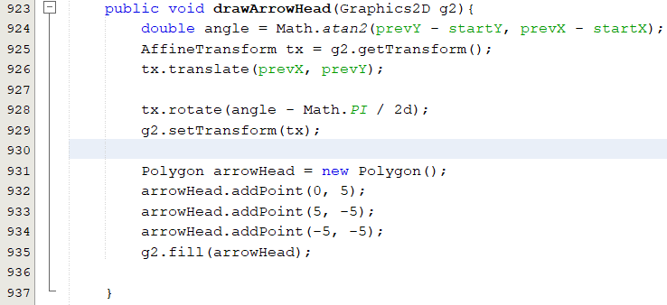

**END**